Boolean Algebra

Boolean Algebra Identities

1. 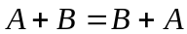 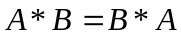 (Communicative Property)
2. 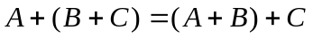 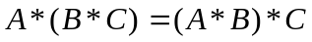 (Associative Property)
3. 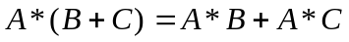 (Distributive Property)
4. 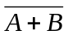= 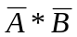 (DeMorgan’s Law)
5. 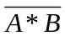 = 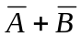 (DeMorgan’s Law)
6. 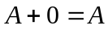 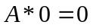
7. 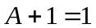 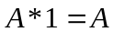
8. 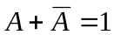 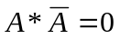
9. 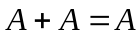 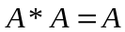
10. 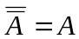

11. 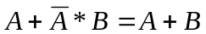
12. 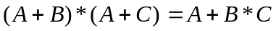
13.
14. 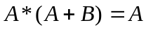
15. 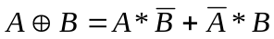
16. 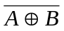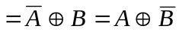

Sample Programs

Simplify the following expression as much as possible:  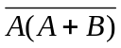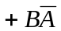 | Using various elementary identities, the expression simplifies as follows:  = 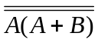*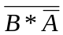  =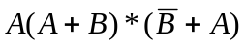  = 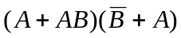  =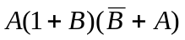  =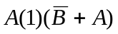  =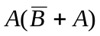  =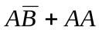  =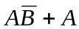  =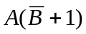  =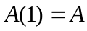
Find all ordered pairs (A, B) that make the following expression TRUE.  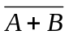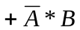 | = (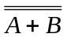)(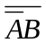)  = (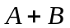)(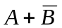)  = 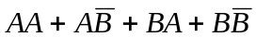  = 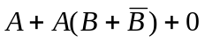  =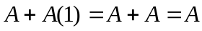  This yields the solutions (1, 0) and (1, 1). This problem, like most Boolean Algebra problems, could also be solved by drawing a truth table with the following seven column headings: A, B, A+B,  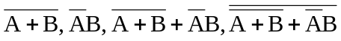.
Simplify the following expression to one that uses only two operators.  (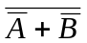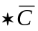) + (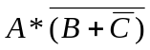) | The evaluation is as follows:  () + ()  = (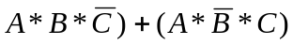  = 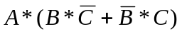  = 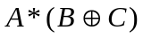  To realize this equation as a circuit, two gates are used: an XOR (input is B and C) and an AND (inputs are A and the output of the XOR gate). The output of the AND is the output of the circuit.

